Steven Brewster, Calvin Burnup
Project #1 Documentation Package
CIS 225-100 Advanced Java Programming

Spring 2011

Table of Contents Page

Project Abstract / Overview 3
UML Diagram 4
Javadocs 5-8
Program Design 9-12
Source Code 13-26
Input 27-28
Output 29

Program Abstract

This program is designed to simulate a bank account program. Customers are read from a list containing their first name, last name, phone number and ID. From there the customer can withdraw or deposit money into his/her bank account. If an invalid amount is entered, such as overdrawing the error will be caught and the user prompted to re-enter correct information. The program also keeps track of the amount of users in the bank system, and if the allotted amount of users becomes full it increases the total space by ten. The program also allows the addition and deletion of users at will and well as finding the index of said persons. Customer information can also be retrieved by looking up only a portion of their information, the customer list can also be sorted alphabetically. The user interface is setup in menu format via a switch case, when the user is finished all data is saved back to the list in updated format.

UML Diagram
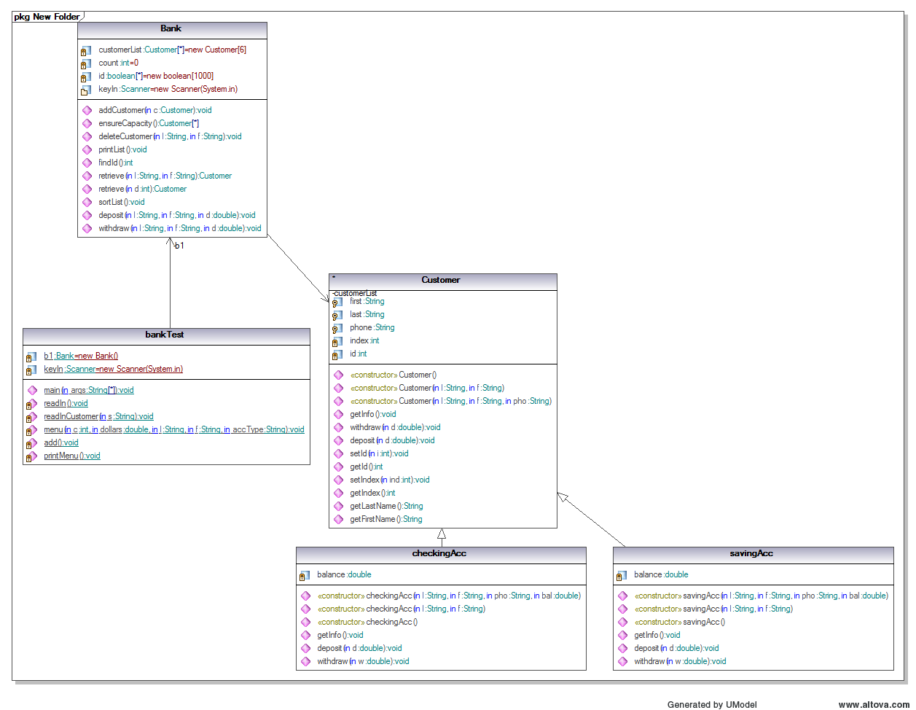

Java Docs

Class Bank
java.lang.Object
Bank

class Bank
extends java.lang.Object

Field Summary
private int | count
private Customer[] | customerList
private boolean[] | id
(package private) java.util.Scanner | keyIn

Constructor Summary
Bank()

Method Summary
void | addCustomer(Customer c)
void | deleteCustomer(java.lang.String l, java.lang.String f)
void | deposit(java.lang.String l, java.lang.String f, double d)
Customer[] | ensureCapacity()
int | findId()
void | printList()
Customer | retrieve(int d)
Customer | retrieve(java.lang.String l, java.lang.String f)
void | sortList()
void | withdraw(java.lang.String l, java.lang.String f, double d)

Methods inherited from class java.lang.Object
clone, equals, finalize, getClass, hashCode, notify, notifyAll, toString, wait, wait, wait

Field Detail

customerList
private Customer[] customerList

count
private int count

id
private boolean[] id

keyIn
java.util.Scanner keyIn
Constructor Detail

Bank
Bank()
Method Detail

addCustomer
public void addCustomer(Customer c)

ensureCapacity
public Customer[] ensureCapacity()

deleteCustomer
public void deleteCustomer(java.lang.String l,
java.lang.String f)

printList
public void printList()

findId
public int findId()

retrieve
public Customer retrieve(java.lang.String l,
java.lang.String f)

retrieve
public Customer retrieve(int d)

sortList
public void sortList()

deposit
public void deposit(java.lang.String l,
java.lang.String f,
double d)

withdraw
public void withdraw(java.lang.String l,
java.lang.String f,
double d)

Program Description

Bank
Customer ARRAY 6
PRIVATE int count = 0
id ARRAY 1000
IF
count EQUALS customerList.length - 1
customerList = ensureCapacity
count++
END IF
temp ARRAY = customerList.length + 10
FOR(i = 0 TO i < customerList.length TO Increment i 1)
temp[i] = customerList[i]
END FOR
RETURN temp
temp_index = c.getIndex()
id SUB c.getID() = false
customerList SUB temp_index = null
FOR(i = temp_index TO i < count TO Increment i 1)
customerList SUB i = customerList SUB i +1
END FOR
count decrement 1
FOR(i = 0 TO i < count TO increment i 1)
ENDFOR
int i = 0
WHILE(id SUB i)
increment i 1
ENDWHILE
id SUB i = true
return i
FOR(int i = 0 TO i < count TO increment i 1)
IF(customerList[i].getLastName().equalsIgnoreCase(l) AND customerList[i].getFirstName().equalsIgnoreCase(f))
c = customerList SUB i
END IF
END FOR
return c
FOR(i = 0 TO i < count TO Increment i 1
IF(customerList[i].getID() == d
c= customerList SUB i
END IF
END FOR
return c
WHILE(flag)
flag = false
FOR(i = 0, TO i < Count -1 TO i Increment 1)
alpha = customerList[i].getLastName();
omega = customerList[i + 1].getLastName();
IF(alpha.compareTo(omega) > 0)
passer = customerList[i];
customerList[i] = customerList[i + 1];
customerList[i].setIndex(i);
customerList[i + 1] = passer;
customerList[i + 1].setIndex(i + 1);
flag = true
END IF
ENF FOR
END WHILE

Customer

PROTECTED String first, last, phone
PROTECTED double balance
PRIVATE int index, id
PRIVATE boolean checking, saving
first = ""
last = ""
phone = ""
balance = 0.0
first = f
last = l
phone = ""
balance = 0.0
first = f
last = l
phone = pho
balance = bal
PRINT"\nCustomer:/b" + last + ",/b" + first"
PRINT"Id/bNumber:/b" + id
PRINT"Phone:/b" + phone
PRINT"Balance:/b" + balance

Source Code
//************************************************
// Name: Steven Brewster, Calvin Burnup
// Course: CSC 225
// Instructor: Wexler
// Project: Bank.java
// Due Date: March 10th 2011
//
//************************************************
//******************************************************************************
// Program Customer.java - The method class, contains all pertanant algorithims.
// Most of the program functions though here.
//******************************************************************************
import java.util.*;
class Bank {
private Customer customerList[] = new Customer[6];
private int count = 0;
private boolean id[] = new boolean[1000];
Scanner keyIn = new Scanner(System.in);
public void addCustomer(Customer c)
{
if ( count == customerList.length - 1 )
customerList = ensureCapacity();
customerList[count] = c;
customerList[count].setIndex(count);
customerList[count].setId(findId());
count++;
}
public Customer[] ensureCapacity ( )
{
Customer temp[] = new Customer[ customerList.length + 5 ];
for (int i = 0; i < customerList.length; i++)
{
temp[i] = customerList[i];
}
return temp;
}
public void deleteCustomer( String l, String f )
{
Customer c = retrieve ( l, f );
int temp_index = c.getIndex();
id[c.getId()] = false;
customerList[temp_index] = null;
for (int i = temp_index; i < count; i++)
{
customerList[i] = customerList[i + 1];
}
count--;
}
public void printList ( )
{
for (int i = 0; i < count; i++)
{
customerList[i].getInfo();
}
}
public int findId ( )
{
int i = 0;
while(id[i])
{
i++;
}
id[i] = true;
return i;
}
public Customer retrieve ( String l, String f )
{
Customer c = new Customer();
int ticker = 0;
for (int i = 0; i < count; i++)
{
if (customerList[i].getLastName().equalsIgnoreCase(l) &&
customerList[i].getFirstName().equalsIgnoreCase(f))
{
c = customerList[i];
}
}
return c;
}
public Customer retrieve ( int d )
{
Customer c = new Customer();
for (int i = 0; i < count; i++)
{
if ( customerList[i].getId() == d )
c = customerList[i];
}
return c;
}
public void sortList ( )
{
Customer passer = new Customer();
String alpha, omega;
boolean flag = true;
while (flag)
{
flag = false;
for (int i = 0; i < count - 1; i++)
{
alpha = customerList[i].getLastName();
omega = customerList[i + 1].getLastName();
if ( alpha.compareTo(omega) > 0 )
{
passer = customerList[i];
customerList[i] = customerList[i + 1];
customerList[i].setIndex(i);
customerList[i + 1] = passer;
customerList[i + 1].setIndex(i + 1);
flag = true;
}
}
}
}
public void deposit ( String l, String f, double d )
{
Customer d1 = this.retrieve(l,f);
d1.deposit(d);
}
public void withdraw ( String l, String f, double d )
{
Customer w1 = this.retrieve(l,f);
w1.withdraw(d);
}
}
//************************************************
// Name: Steven Brewster, Calvin Burnup
// Course: CSC 225
// Instructor: Wexler
// Project: Customer.java
// Due Date: March 10th 2011
//
//************************************************
//******************************************************************************
// Program Customer.java - Contains initial contrsuctors and calls for methods.
// The Parent class of Savings and Checking.
//******************************************************************************
import java.util.*;
public class Customer {
protected String first, last, phone;
private int index, id;
public Customer()
{
first = "";
last = "";
phone = "";
}
public Customer(String l, String f)
{
first = f;
last = l;
phone = "";
}
public Customer(String l, String f, String pho)
{
first = f;
last = l;
phone = pho;
}
public void getInfo ()
{
System.out.println("\nCustomer: " + last + ", " + first);
System.out.println("Id Number: " + id);
System.out.println("Phone: " + phone);
}
public void withdraw ( double d )
{ }
public void deposit ( double d )
{ }
public void setId ( int i )
{
id = i;
}
public int getId ( )
{
return id;
}
public void setIndex ( int ind )
{
index = ind;
}
public int getIndex ( )
{
return index;
}
public String getLastName ( )
{
return last;
}
public String getFirstName ( )
{
return first;
}
}

class checkingAcc extends Customer {
private double balance;
public checkingAcc ( String l,
String f,
String pho,
double bal )
{
super(l, f, pho);
balance = bal;
}
public checkingAcc ( String l,
String f )
{
super(l, f);
balance = 0.0;
}
public checkingAcc ( )
{
super();
balance = 0.0;
}
public void getInfo ()
{
super.getInfo();
System.out.println("Checking account balance: " + balance);
}
public void deposit ( double d )
{
if ( d < 0 )
System.out.println("\n**Error: Deposit cannot be negative**");
else {
balance += d;
super.getInfo();
System.out.println("Amount deposited: " + d);
System.out.println("New balance: " + balance);
}
}
public void withdraw ( double w )
{
if ( w >= balance )
{
System.out.println("\n**Error: Requested funds exceeds available balance**");
w = balance;
} else if ( w < 0 )
System.out.println("\n**Error: Invalid withdrawal amount**");
else {
balance -= w;
super.getInfo();
System.out.println("Amount withdrawn: " + w);
System.out.println("Remaining balance: " + balance);
}
}
}
class savingAcc extends Customer{
private double balance;
public savingAcc ( String l,
String f,
String pho,
double bal )
{
super(l, f, pho);
balance = bal;
}
public savingAcc ( String l,
String f )
{
super(l, f);
balance = 0.0;
}
public savingAcc ( )
{
super();
balance = 0.0;
}
public void getInfo ()
{
super.getInfo();
System.out.println("Savings account balance: " + balance);
}
public void deposit ( double d )
{
if ( d < 0 )
System.out.println("\n**Error: Deposit cannot be negative**");
else {
balance += d;
super.getInfo();
System.out.println("Amount deposited: " + d);
System.out.println("New balance: " + balance);
}
}
public void withdraw ( double w )
{
if ( w >= balance )
{
System.out.println("\n**Error: Requested funds exceeds available balance**");
w = balance;
} else if ( w < 0 )
System.out.println("\n**Error: Invalid withdrawal amount**");
else {
balance -= w;
super.getInfo();
System.out.println("Amount withdrawn: " + w);
System.out.println("Remaining balance: " + balance);
}
}
}
import java.io.*;
import java.util.*;
class bankTest {
private static Bank b1 = new Bank();
private static Scanner keyIn = new Scanner(System.in);
public static void main ( String[] args )
{
int choice = 0;
double emptyDouble = 0.0;
String emptyString = "";
readIn();
//Sort customer list
printMenu();
System.out.println("Sort the list");
menu(6,emptyDouble,emptyString,emptyString,emptyString);
//Print the list
printMenu();
System.out.println("Print the list");
menu(7,emptyDouble,emptyString,emptyString,emptyString);
//Withdraw $125 from Smith John account
printMenu();
System.out.println("Withdraw $125 from Smith John account");
menu(3,125.00,"Smith","John","checking");
//Withdraw $300 from Smith John account
printMenu();
System.out.println("Withdraw $300 from Smith John account");
menu(3,300.00,"Smith","John","checking");
//Deposit $500 to Clinton Hillery's account
printMenu();
System.out.println("Deposit $500 to Clinton Hillery's account");
menu(2,500.00,"Clinton","Hillery","saving");
//Remove Obama Barak from the list
printMenu();
System.out.println("Remove Obama Barak from the list");
menu(5,emptyDouble,"Obama","Barak",emptyString);
menu(7,emptyDouble,emptyString,emptyString,emptyString);
//Deposit -$100 into George Bush account
printMenu();
System.out.println("Deposit -$100 into George Bush account");
menu(2,-100.00,"Bush","George","saving");
menu(7,emptyDouble,emptyString,emptyString,emptyString);
//Withdraw -$50 from Grove Kavin account
printMenu();
System.out.println("Withdraw -$50 from Grove Kavin account");
menu(3,-50.00,"Grove","Kavin","checking");
}
private static void readIn()
{
FileReader theFile;
BufferedReader fileIn = null;
String oneLine= "";
try {
theFile = new FileReader( "customerlist.txt" );
fileIn = new BufferedReader( theFile );
while( ( oneLine = fileIn.readLine( ) ) != null )
readInCustomer ( oneLine );
}
catch( Exception e )
{ System.out.println( e ); }
}
private static void readInCustomer(String s)
{
String splitter[] = s.split(",");
if (splitter[4].equals("checking"))
{
checkingAcc c1 = new checkingAcc(splitter[0],
splitter[1],
splitter[2],
Double.parseDouble(splitter[3]));
b1.addCustomer(c1);
}
if (splitter[4].equals("saving"))
{
savingAcc s1 = new savingAcc(splitter[0],
splitter[1],
splitter[2],
Double.parseDouble(splitter[3]));
b1.addCustomer(s1);
}
}
private static void menu ( int c,
double dollars,
String l,
String f,
String accType )
{
switch (c)
{
case 1: add();
break;
case 2: b1.deposit(l,f,dollars);
break;
case 3: b1.withdraw(l,f,dollars);
break;
case 4: b1.retrieve(l,f);
break;
case 5: b1.deleteCustomer(l,f);
break;
case 6: b1.sortList();
break;
case 7: b1.printList();
break;
}
}
private static void add ( )
{
String l, f, pho;
double bal;
System.out.print("Customer's last name: ");
l = keyIn.next();
System.out.print("Customer's first name: ");
f = keyIn.next();
System.out.print("Customer's phone number: ");
pho = keyIn.next();
System.out.print("Starting balance: ");
bal = Double.parseDouble(keyIn.next());
checkingAcc c1 = new checkingAcc(l,f,pho,bal);
b1.addCustomer(c1);
System.out.println("+++New customer successfully created+++");
}
private static void printMenu()
{
System.out.print("\n1. Add a customer\n" +
"2. Deposit\n" +
"3. Withdraw\n" +
"4. Retrieve a customer\n" +
"5. Remove a customer\n" +
"6. Sort the customers (in ascending order)\n" +
"7. Print the list of customers ( last name first name, id, and balance)\n" +
"8. Quit\n" +
"--> ");
}
}

Input
//Sort customer list
printMenu();
System.out.println("Sort the list");
menu(6,emptyDouble,emptyString,emptyString,emptyString);
//Print the list
printMenu();
System.out.println("Print the list");
menu(7,emptyDouble,emptyString,emptyString,emptyString);
//Withdraw $125 from Smith John account
printMenu();
System.out.println("Withdraw $125 from Smith John account");
menu(3,125.00,"Smith","John","checking");
//Withdraw $300 from Smith John account
printMenu();
System.out.println("Withdraw $300 from Smith John account");
menu(3,300.00,"Smith","John","checking");
//Deposit $500 to Clinton Hillery's account
printMenu();
System.out.println("Deposit $500 to Clinton Hillery's account");
menu(2,500.00,"Clinton","Hillery","saving");
//Remove Obama Barak from the list
printMenu();
System.out.println("Remove Obama Barak from the list");
menu(5,emptyDouble,"Obama","Barak",emptyString);
menu(7,emptyDouble,emptyString,emptyString,emptyString);
//Deposit -$100 into George Bush account
printMenu();
System.out.println("Deposit -$100 into George Bush account");
menu(2,-100.00,"Bush","George","saving");
menu(7,emptyDouble,emptyString,emptyString,emptyString);
//Withdraw -$50 from Grove Kavin account
printMenu();
System.out.println("Withdraw -$50 from Grove Kavin account");
menu(3,-50.00,"Grove","Kavin","checking");

Output
Output:

ÏCustomer: Bush, George
ÏÏ§ÏId Number: 4
ÏÏ§ÏPhone: (607)567-2345
ÏÏ§ÏSavings account balance: 200.00
ÏÏ§Ï
ÏÏ§ÏCustomer: Clinton, Hillery
ÏÏ§ÏId Number: 5
ÏÏ§ÏPhone: (212)456-2378
ÏÏ§ÏChecking account balance: 1500.50
ÏÏ§Ï
ÏÏ§ÏCustomer: Grove, Kavin
ÏÏ§ÏId Number: 1
ÏÏ§ÏPhone: (716)111-3356
ÏÏ§ÏChecking account balance: 2000.53
ÏÏ§Ï
ÏÏ§ÏCustomer: Palin, Sara
ÏÏ§ÏId Number: 3
ÏÏ§ÏPhone: (509)888-1234
ÏÏ§ÏSavings account balance: 6120.55
ÏÏ§Ï
ÏÏ§ÏCustomer: Smith, John
ÏÏ§ÏId Number: 0
ÏÏ§ÏPhone: (212)444-7866
ÏÏ§ÏSavings account balance: 200.60
ÏÏ§Ï
ÏÏ§Ï**Error: Invalid withdrawal amount**

